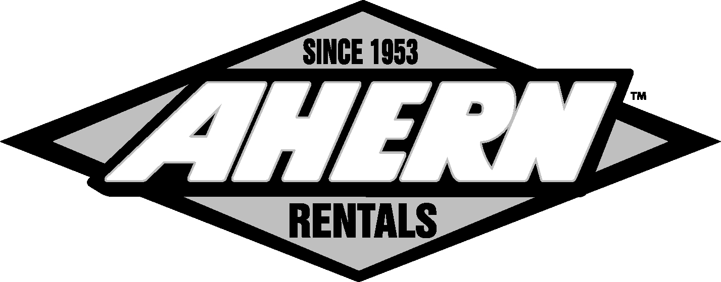
Management Training Code of Conduct

To: Management Training Attendees
From: Human Resources
Subject: Code of Conduct- Management Training
Date: 7/14/08
Cc: Personnel File

Ahern Rentals, Inc. has constructed a six (6) session management training course designed to prepare our managers to properly facilitate, communicate, plan and execute. The course is taught primarily on three learning levels:
- The cognitive level deals with basic information important to subjects that directly or indirectly relate to management.
- The affective level deals with socialization, attitude, and sensitivities related to management.
- The performance level deals with performing the tasks required of managers.
Course Schedule: 7/1, 7/2, 7/15, 7/16, 7/29, and 7/30/2008
Session Times and Duration: 8:00 – 11:00 am (PST) 3 Hours; 1:00 – 4:00 pm (PST) 3 Hours
*There are two sessions per day. The same information is included in both sessions within the same training day.*
Expectations:
- Attendance is mandatory.
- Only emergency or business calls are allowed. Telephone calls should occur outside of the training area.
- During the course, each attendee is required to participate in the discussions and exercises.
The training sessions are carefully arranged to allow maximum learning in a minimum amount of time.
Rules have been established to ensure each individual is treated with courtesy and respect, and so that each person receives the most from the training. These rules will also reinforce some of the skills and knowledge you need to fully perform your management duties. These rules are not exhaustive and can be found in the Employee Handbook.

Harassment
The Company is committed to providing a work environment free of sexual or other unlawful harassment. As part of its commitment to equal opportunity, the Company strictly prohibits harassment of employees based on race, religious creed, color, sex, national origin, ancestry, age, sexual orientation, physical or mental disability, marital status, medical condition, pregnancy or childbirth, or any other classification that is protected under applicable state, federal or local laws. Harassment includes all forms of offensive or unwelcome physical or verbal conduct that interferes with an employee's work or creates an offensive or hostile working environment. All such harassment is unacceptable and will not be tolerated. The Company’s anti-harassment policy applies to all Company employees, as well as to customers, vendors and other persons at the workplace whom the Company knows or has reason to suspect are violating this policy. All Company personnel are expected to avoid any conduct that could be construed as harassment by any employee.
It is your responsibility as an employee of the Company to immediately report harassing behavior, whether it is directed at you or is something that you have seen or heard directed at someone else, to the Human Resources Department or your supervisor. Any manager or supervisor who learns of or observes harassing behavior, or any manager or supervisor who receives a complaint about this kind of behavior, must immediately report the behavior or complaint to the Human Resources Department.

Sexual Harassment
Prohibited sexual harassment includes, but is not limited to, the following behaviors:
- Verbal conduct such as insults, derogatory jokes or comments, slurs or unwanted sexual advances, invitations or comments
- Visual conduct such as derogatory and/or sexually-oriented posters, photography, cards, cartoons, drawings or gestures
- Physical conduct such as assault, unwanted touching, blocking normal movement or interfering with work because of sex
- Threats and demands to submit to sexual requests as a condition of continued employment, or to avoid some other loss, and offers of employment benefits in return for sexual favors
- Retaliation for having reported or threatened to report harassment.
Sexual harassment includes unwelcome sexual advances, requests for sexual favors, and other verbal or physical conduct of a sexual nature when one of the following occurs:
- Submission to such conduct is made either explicitly or implicitly as a term or condition of an individual’s employment.
- Submission to or rejection of such conduct by an individual is used as the basis for employment decisions affecting the individual.
- Such conduct has the purpose or effect of unreasonably interfering with an individual’s work performance or creating an intimidating, hostile, or offensive working environment.
If you believe that you have been harassed, sexually or otherwise, or if you have witnessed such harassment, you must provide a complaint to your immediate supervisor or to the Human Resources Department. Your complaint should include details of the incident or incidents, names of the individuals involved and names of any witnesses. Supervisors will refer all harassment complaints to Human Resources. The Company or its designated representative will immediately begin a thorough investigation of the harassment charges.
If the Company determines that harassment has occurred, effective remedial action will be taken in accordance with the circumstances involved. Any employee determined by the Company to be responsible for unlawful harassment will be subject to appropriate disciplinary action, up to and including termination. The Company will not retaliate against an employee for filing a complaint in good faith or participating in any investigation in good faith and will not tolerate or permit retaliation by management, employees or co-workers. If you believe that you have been retaliated against, report it to Human Resources immediately. The most important thing is that you immediately report any incident of harassment so that it can be investigated and the conduct, if inappropriate, can be stopped.

Workplace Violence
Our Company does not tolerate violence in the workplace. Acts or threats of physical violence including intimidation and/or harassment which involve or affect the Company will not be tolerated. You have a responsibility to immediately report any act or threat of violence to your Supervisor.
Prohibited conduct includes, but is not limited to:
- Injuring another person physically
- Engaging in behavior that creates a reasonable fear of injury to another person
- Engaging in behavior that subjects another individual to extreme emotional distress
- Possessing, brandishing, or using a weapon that is not required by the individual’s position while on company premises or engaged in company business
- Intentionally damaging property
- Threatening, intimidating, coercing, or interfering with guests, customers, supervisors, or other employees
- Committing injurious acts motivated by, or related to, domestic violence or sexual harassment
- Retaliating against any employee who, in good faith, reports a violation of this policy

General Rules/Standards of Conduct
We consider our employees representatives of our Company. Anyone representing Ahern Rentals (the “Company”) is expected to maintain high standards of conduct. This directly impacts the Company’s reputation for acting ethically, with integrity, and to the highest professional standards. Therefore, all employees of Ahern Rentals shall strive at all times to avoid acting in such a way that, accidentally or otherwise, reflects negatively on the Company.
Ahern Rentals does not prescribe limits to or interfere with the way the staff chooses to enjoy their personal time. Employees should take care to ensure that personal motivations and interests do not conflict with those of the Company, and that they do not appear to do so from the perception of an outside observer.

All attendees of the Management Training shall understand that Ahern Rentals does not condone the behavior discussed here. All employees will comply; if they do not, strict consequences will result. Each training participant must sign below acknowledging that he/she has read this document in its entirety and understands the guidelines mentioned above as well as his/her obligation comply and report inappropriate behavior to his/her supervisor or Human Resources.

Management Training Attendee, print and sign below:
Employee Name:
(Please Print)
Employee Signature:

Ahern Rentals, Inc.
Human Resources
1726 W. Bonanza Road
Las Vegas, Nevada 89106
(702) 851-3701

